Overview:
- Student support for Brightspace is covered in 2 online locations:
- In the brightspaceforstudents web page
- In the FE/HE module outlines in Brightspace

Web site:
- Written specifically for students: https://www.uhi.ac.uk/en/students/support/brightspaceforstudents/
How do you reach it?
- Directly from the link above, or
- From UHI web site
  - If a student starts at www.uhi.ac.uk – then click on Current Students – this takes them to MyDay (see below)
- Directly from MyDay
  - Path: Current students > Support > Extra support – Brightspace
  - Alternatively: Support for Students > Support page > Extra support – Brightspace

The site itself
https://www.uhi.ac.uk/en/students/support/brightspaceforstudents/
- Part of the range of Support for Students area of the UHI web site
  - The webpage is the key resource we are directing students to.
  - There has been an extensive promotional campaign, which began at the beginning of April and will run till the start of the new academic year, directing students to the webpage.
  - The site explains why we are introducing Brightspace, what we are doing to prepare, what students can do to prepare etc so that staff know the key messages we would like to convey to students.
  - In How can I prepare? the page directs students to the ESS Getting Online resource: http://induction.uhi.ac.uk/updated/Using-technologies/Getting-online/brightspace.html
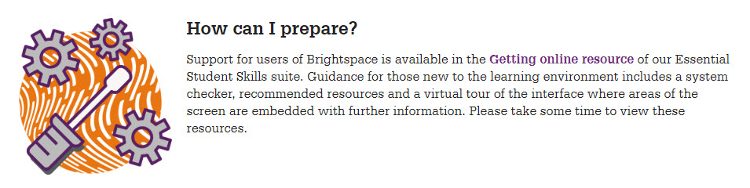
  - 2 key pages in the Getting online RLO:
    - Support tabs (system check, videos, articles, Bsp help);
    - Brightspace ‘tours’ (2 pages: Institutional and Module home pages; with lots of ‘click to activate pop-ups’ e.g. below). NB: The idea here is to give students who haven’t yet got access to a unit/module a feel for what Brightspace looks like and what the different elements on the page are for.
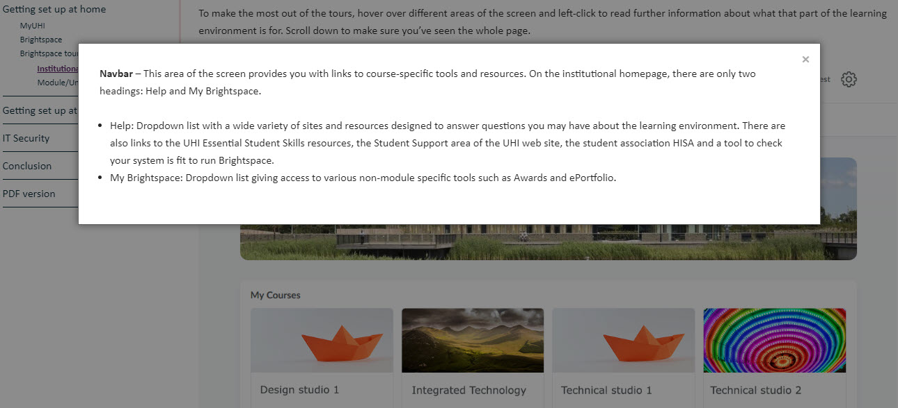
  - Support & questions: a studentengagement@uhi.ac.uk email address
  - FAQs – 2 currently but will be added to

Module outlines:
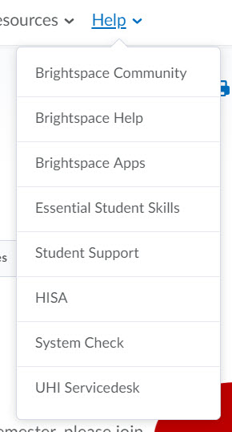
- There is a good deal of support for students within each unit/module they are enrolled on, via the Help dropdown in the navbar. The dropdown contains 8 links:
  - Brightspace Community - the biggest by far (massive amount of constantly improving content in 5 subsets: Topics, Groups, Youtube channel, etc. – each of which contain significant amounts of info based around 3 different roles: Learner, Instructor and Administrator) – focus on Topics > Learners (8 sub-cats; 29 articles); Video tutorials > Playlists > Navigate Brightspace for Learners (23)
  - Brightspace Help – More minimal design than Community but able to access a significant amount of info, inc. video – anticipates people using a search bar to specify what they want; but there’s also a Learners dropdown
  - Brightspace Apps – really aimed at teaching staff - the product most likely to be used by students is Pulse, a mobile app (Android/Apple) compatible with Bsp though this isn’t mentioned in this link. Likely to be replaced in the near future.
  - Essential Student Skills – updated version, only available through Brightspace at present (where all mentions of Blackboard have been replaced/updated)
  - HISA – Student Association web site
  - System Check – quick check, esp. useful if you’re on a new machine
  - UHI Servicedesk – another option for requesting assistance

Resits
- Overview of process/advice (Lesley Murray)

